**FluentBits Agent install**

1. [**下载安装**](https://docs.fluentbit.io/manual/installation/getting-started-with-fluent-bit)**(本文以 Ubuntu 18.04 为例，其他系统可参考链接)**

| **wget -qO - https://packages.fluentbit.io/fluentbit.key | sudo apt-key add -**  **echo deb https://packages.fluentbit.io/ubuntu/bionic bionic main >> /etc/apt/sources.list**  **sudo apt-get update**  **sudo apt-get install td-agent-bit** |
| --- |

1. **创建 service account, 分配 Agent 写入日志和指标所需权限**

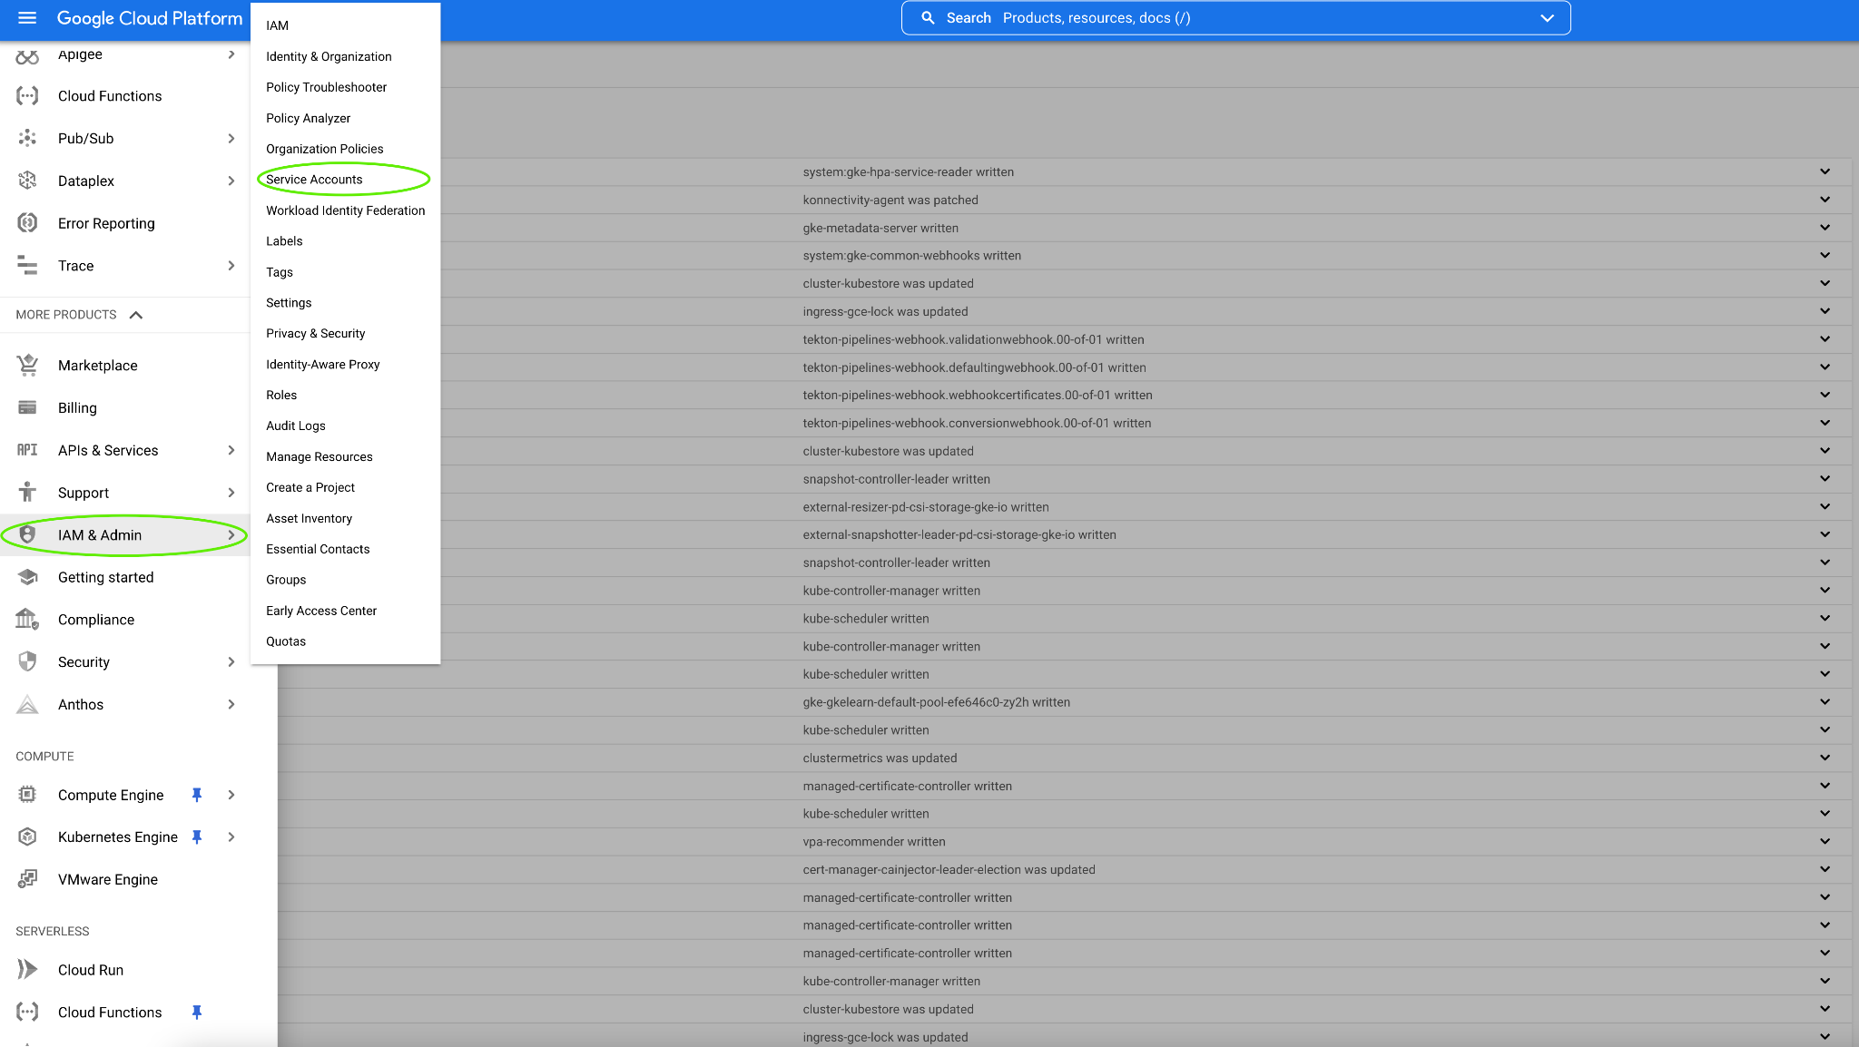

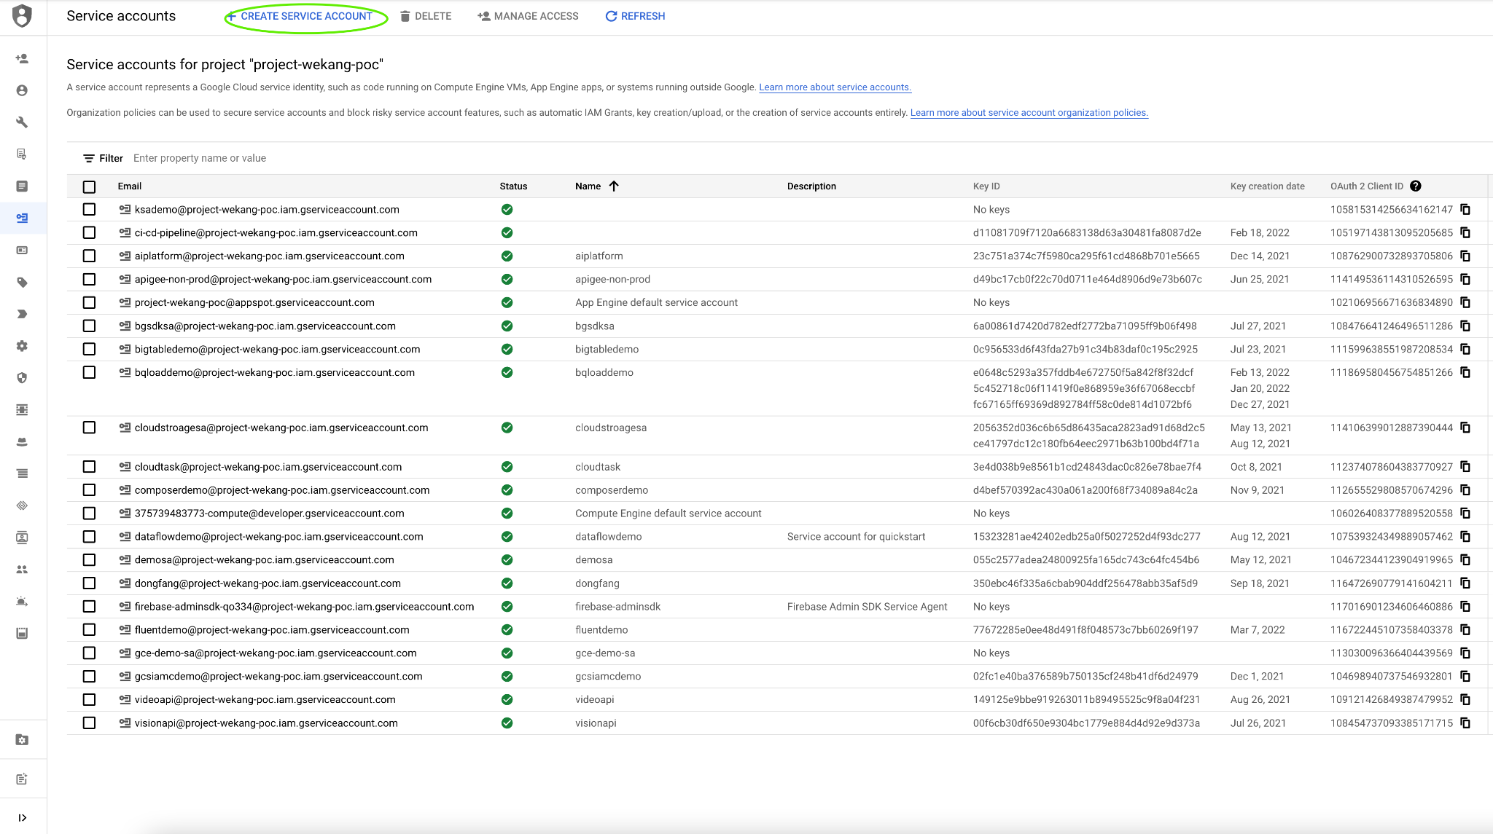

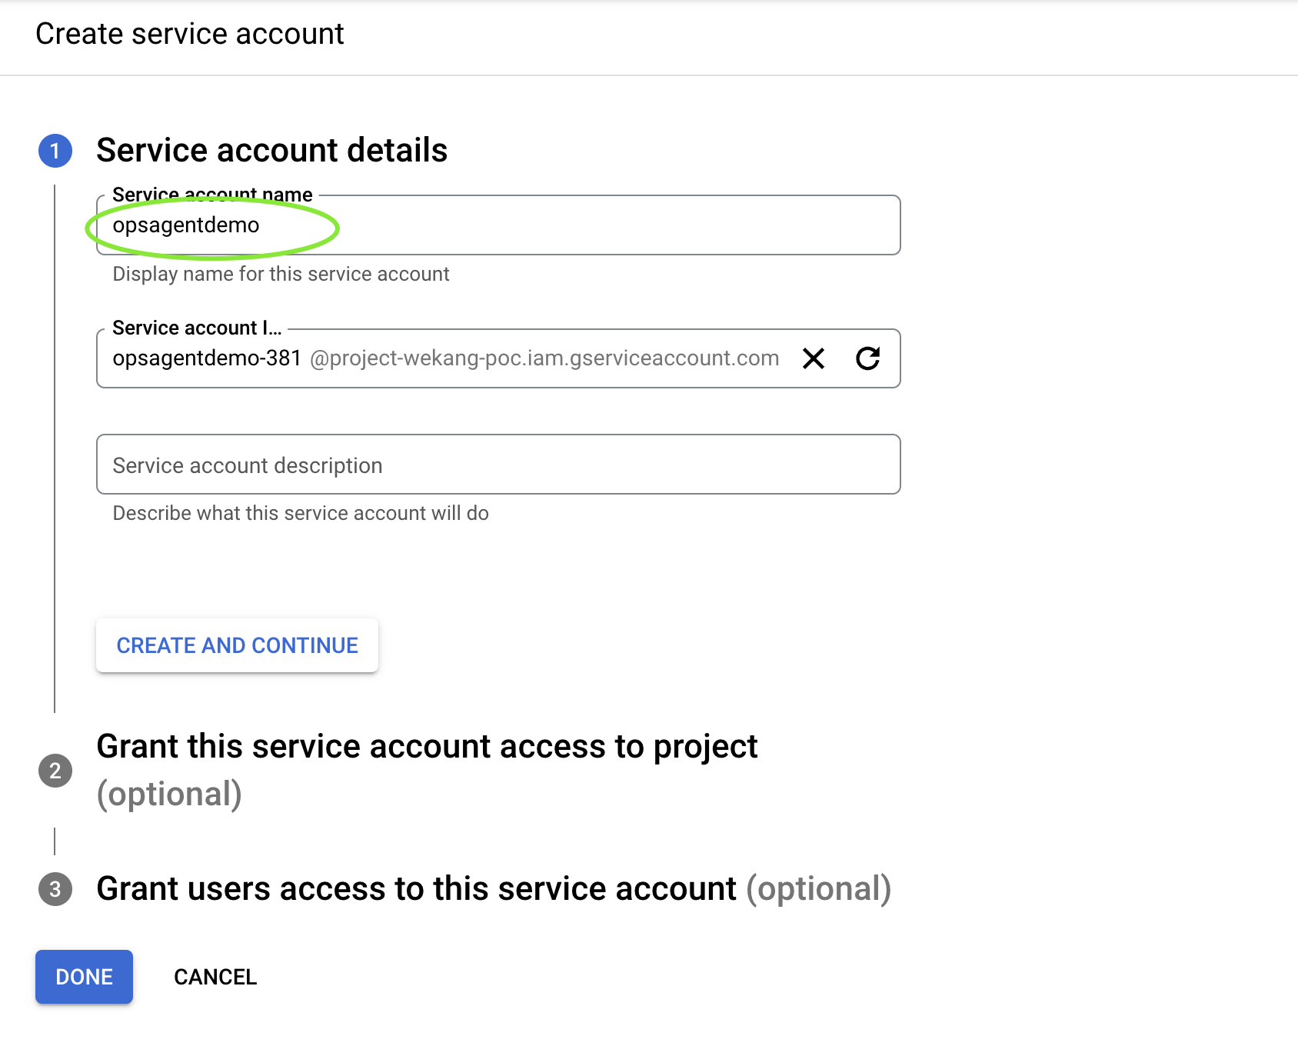

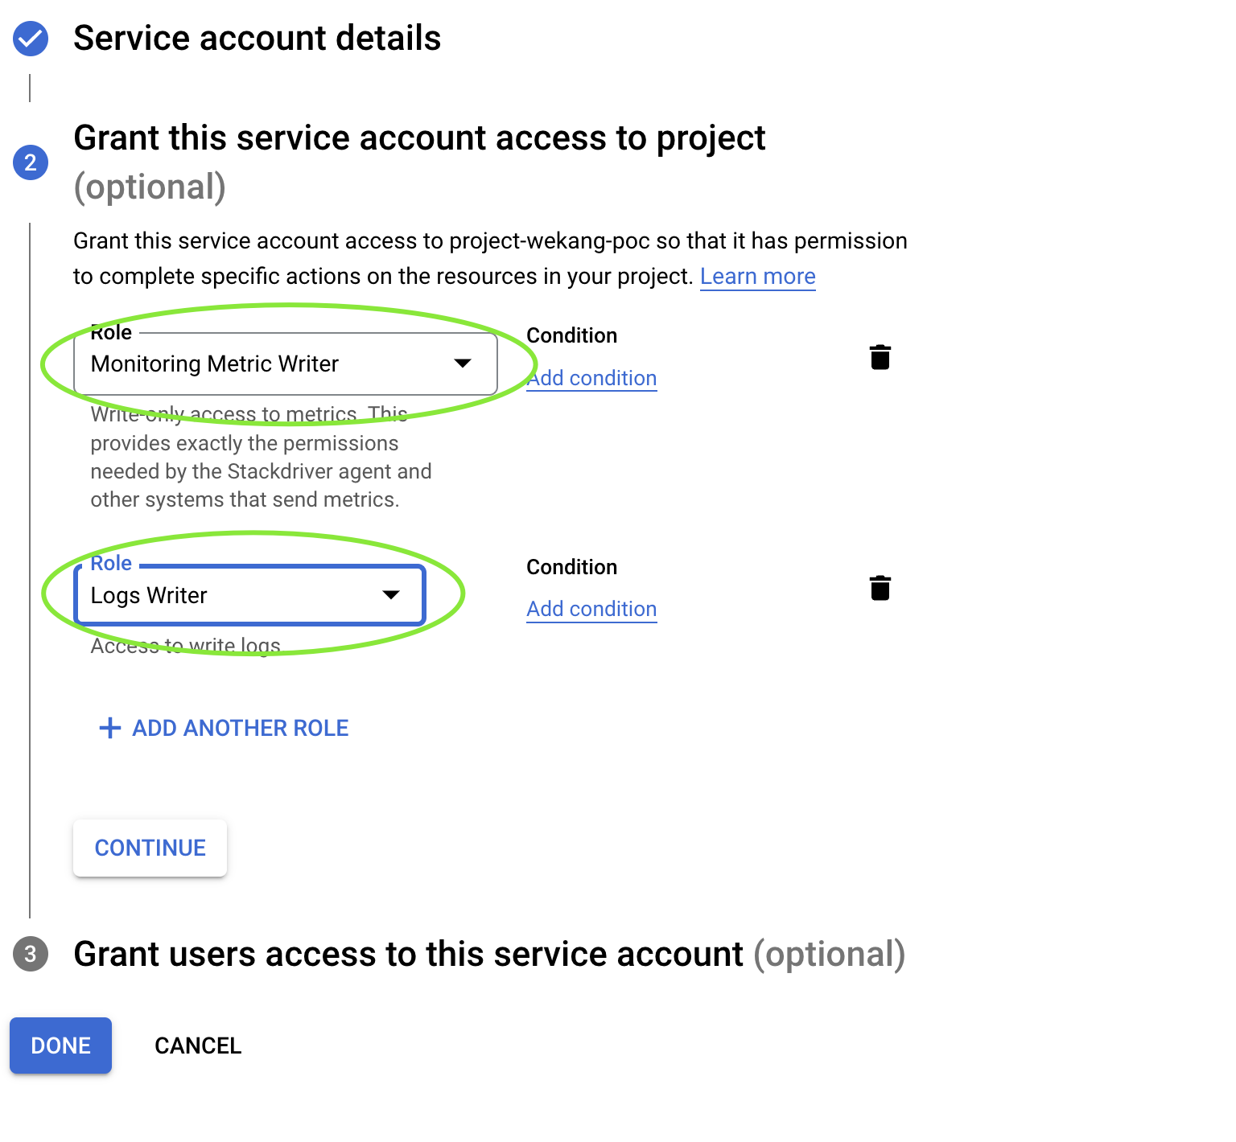

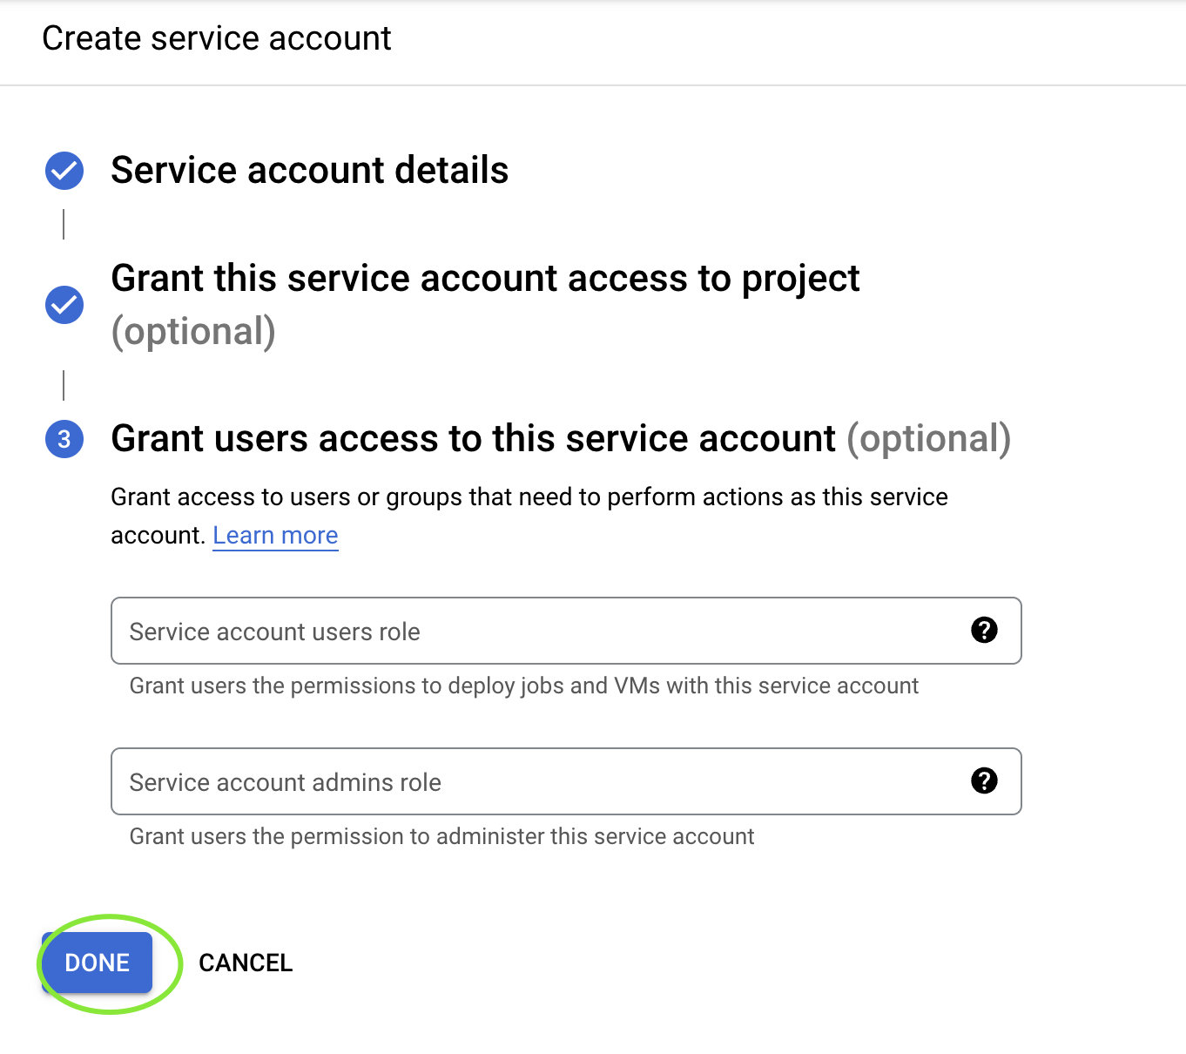

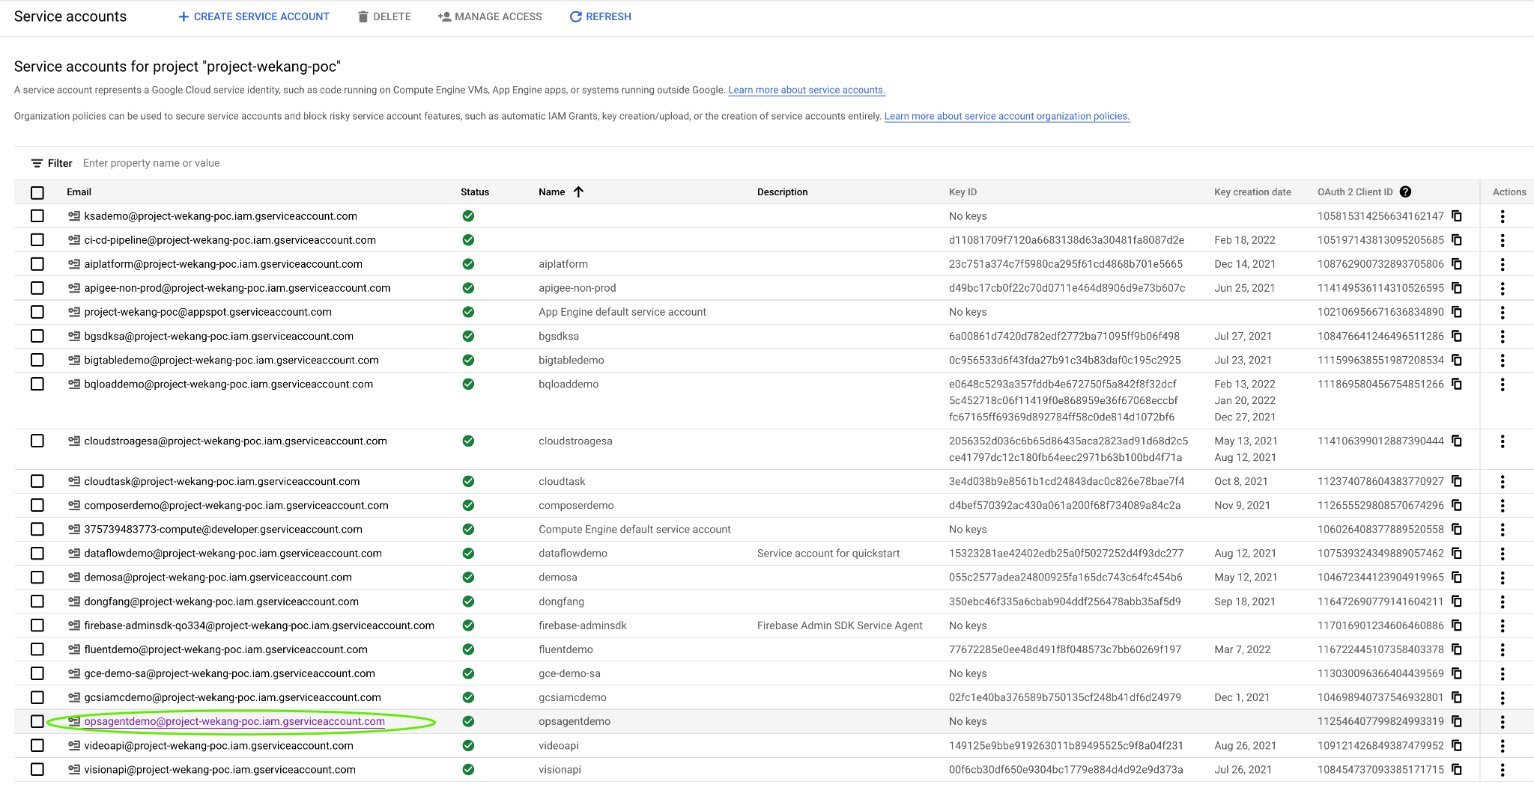

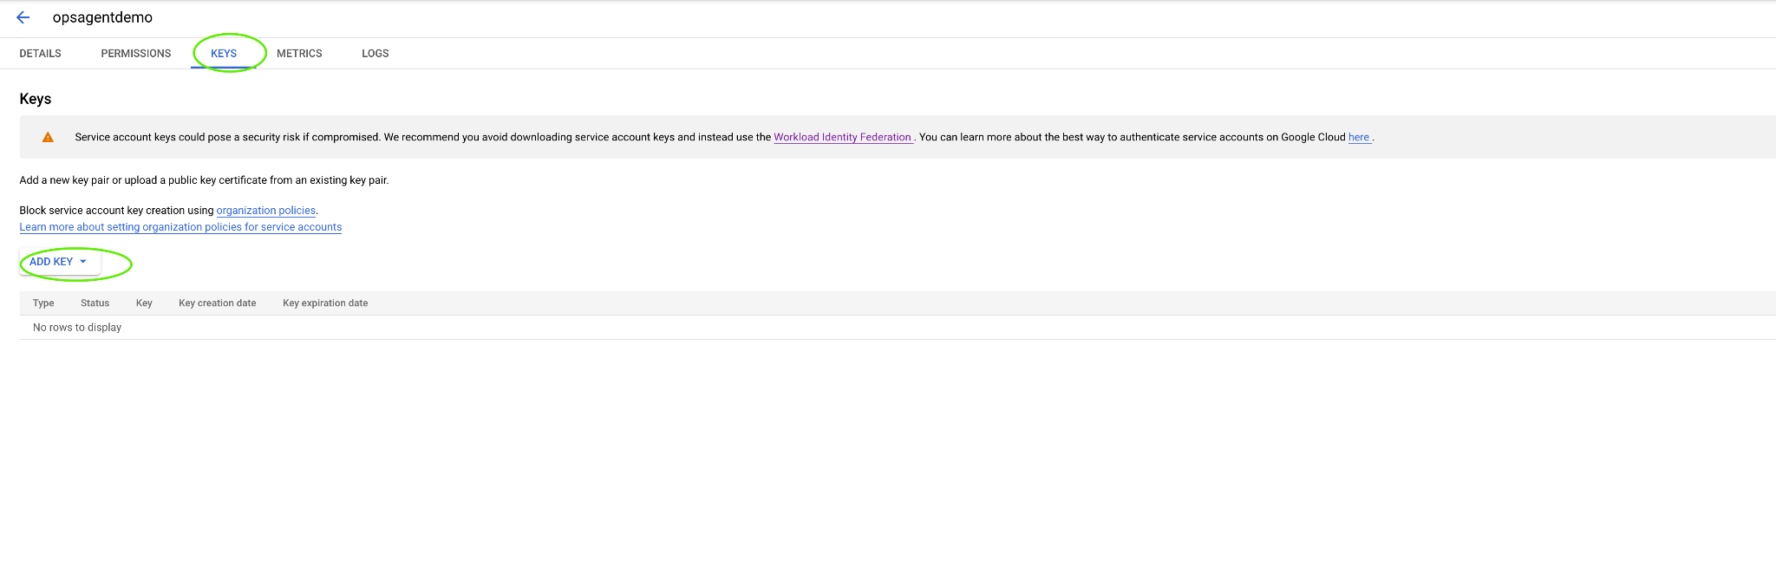

1. **将创建好的 service account 所生成的 Key 密钥上传的日志 agent 所在主机**

| **scp xxx.json xxx@20.84.58.205:/etc/google/auth/application_default_credentials.json** |
| --- |

1. **（可选）以收集 JSON 格式文本日志为例，更多**[**配置选项参考**](https://docs.fluentbit.io/manual/pipeline/outputs/stackdriver)

**修改 fluentbits 配置文件（路径 /etc/td-agent-bit/td-agent-bit.conf）**

| **[SERVICE]**  **# Flush**  **# =====**  **# set an interval of seconds before to flush records to a destination**  **flush 5**  **# Daemon**  **# ======**  **# instruct Fluent Bit to run in foreground or background mode.**  **daemon Off**  **# Log_Level**  **# =========**  **# Set the verbosity level of the service, values can be:**  **#**  **# - error**  **# - warning**  **# - info**  **# - debug**  **# - trace**  **#**  **# by default 'info' is set, that means it includes 'error' and 'warning'.**  **log_level debug**  **# Parsers File**  **# ============**  **# specify an optional 'Parsers' configuration file**  **parsers_file parsers.conf**  **# Plugins File**  **# ============**  **# specify an optional 'Plugins' configuration file to load external plugins.**  **plugins_file plugins.conf**  **# HTTP Server**  **# ===========**  **# Enable/Disable the built-in HTTP Server for metrics**  **http_server On**  **http_listen 0.0.0.0**  **http_port 2020**  **# Storage**  **# =======**  **# Fluent Bit can use memory and filesystem buffering based mechanisms**  **#**  **# - https://docs.fluentbit.io/manual/administration/buffering-and-storage**  **#**  **# storage metrics**  **# ---------------**  **# publish storage pipeline metrics in '/api/v1/storage'. The metrics are**  **# exported only if the 'http_server' option is enabled.**  **#**  **storage.metrics on**  **# storage.path**  **# ------------**  **# absolute file system path to store filesystem data buffers (chunks).**  **#**  **# storage.path /tmp/storage**  **# storage.sync**  **# ------------**  **# configure the synchronization mode used to store the data into the**  **# filesystem. It can take the values normal or full.**  **#**  **# storage.sync normal**  **# storage.checksum**  **# ----------------**  **# enable the data integrity check when writing and reading data from the**  **# filesystem. The storage layer uses the CRC32 algorithm.**  **#**  **# storage.checksum off**  **# storage.backlog.mem_limit**  **# -------------------------**  **# if storage.path is set, Fluent Bit will look for data chunks that were**  **# not delivered and are still in the storage layer, these are called**  **# backlog data. This option configure a hint of maximum value of memory**  **# to use when processing these records.**  **#**  **# storage.backlog.mem_limit 5M**  **[INPUT]**  **name cpu**  **tag cpu.local**  **# Read interval (sec) Default: 1**  **interval_sec 1**  **[INPUT]**  **name tail**  **path /tmp/fdemo/data.log**  **parser json**  **tag fdemo**  **[OUTPUT]**  **Name stackdriver**  **Match fdemo**  **google_service_credentials /etc/google/auth/application_default_credentials.json**  **resource global**  **[OUTPUT]**  **name stdout**  **match \*** |
| --- |

**生成测试日志**

| **echo '{"code": "structured-log-code", "message": "This is a log from the log file at test-structured-log.log"}' >> /tmp/fdemo/data.log** |
| --- |

**在 Cloud Logging 服务中过滤**

| **logName="projects/project-wekang-poc/logs/fdemo"** |
| --- |